05th September 2016

WTCC Lopez makes it three Championships in a row

The Argentine Jose Maria “Pechito” Lopez secured* subject to official confirmation, his third consecutive title in the FIA World Touring Car Championship during the race weekend in Japan. A dominant force since he joined the Championship after a one-off race taster back in 2013, Lopez has led since 2014 to this date and Citroen are surely delighted with his performance and their efforts.

With a strong Citroen works project and top level team mates including 4-times world Champion Yvan Muller and up till last year, Sebastien Loeb, “Pechito” has flown to the very top of the Motorsports scene and will now seek new challenges in other Championships.

The opening race in Japan’s Twin Ring Motegi, proved as exciting as anticipated. An incredible performance from Norbert Michelisz and a lights to flag race, guaranteed a Honda top three on the podium, on home soil and making the Honda dream come true on the day. Michelisz, Huff and Monteiro in that order gave all Honda fans serious cause for celebration.

However Citroen’s spirits were not dampened by the fantastic result from Honda. Their own Lopez runaway leader, fought well to secure a fourth place and valuable points to put the Driver’s title within his grasp. The FIA World Touring Car Championship with the Japanese Tyre manufacturer YOKOHAMA as exclusive tyre supplier was ready for Lopez to extend his legend in front of the crowds and fans.

On the second race, Lopez did not only lead comfortably but was generous too when he stepped off the gas a little to allow his team mate Yvan Muller through in the latter part of the race and earn his team mate his first victory in 2016 which also enabled him to tie on 199 points with Tiago Monteiro in the 2nd place, in the overall Drivers ranking.

Lopez had done enough with his second place. The FIA World Touring Car Championship title had been secured for a third consecutive season.

Nestor Girolami marked his return to WTCC action with a meritorious 5th place for Polestar Cyan Racing in the Main Race, and Catsburg and the veteran Italian Tarquini scored points for LADA.

Jose Maria Lopez did not hide his emotions and expressed his delight and exclaimed he felt “one of the happiest people in the world”. He was also very grateful and complimentary of Citroen Racing and the hard effort put by so many behind the scenes, whilst he also had a word to say that Yvan Muller was still the greatest in WTCC.

*Subject to confirmation by the FIA, because the WTCC promoter, Eurosport Events, has made a request to the FIA Touring Car Commission to cancel the WTCC Race of Thailand, which will mean the championship will run over 11 race weekends rather than 12, subject to final ratification by the FIA World Motor Sport Council.

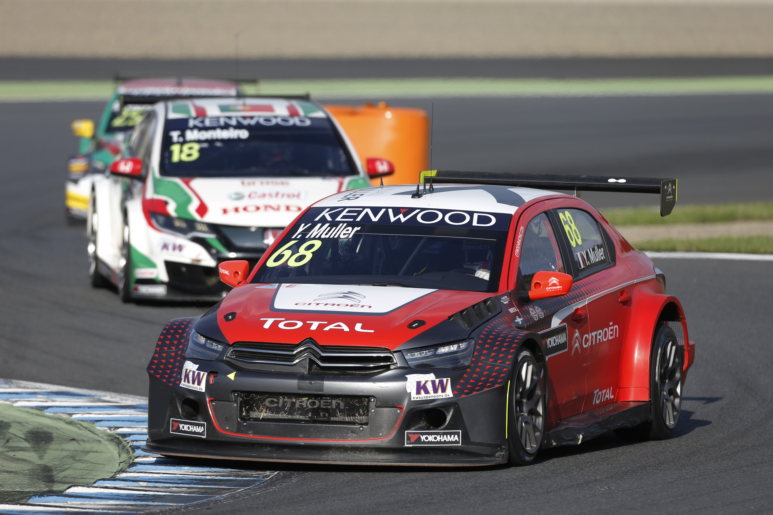
Muller and Monteiro to battle for 2nd place

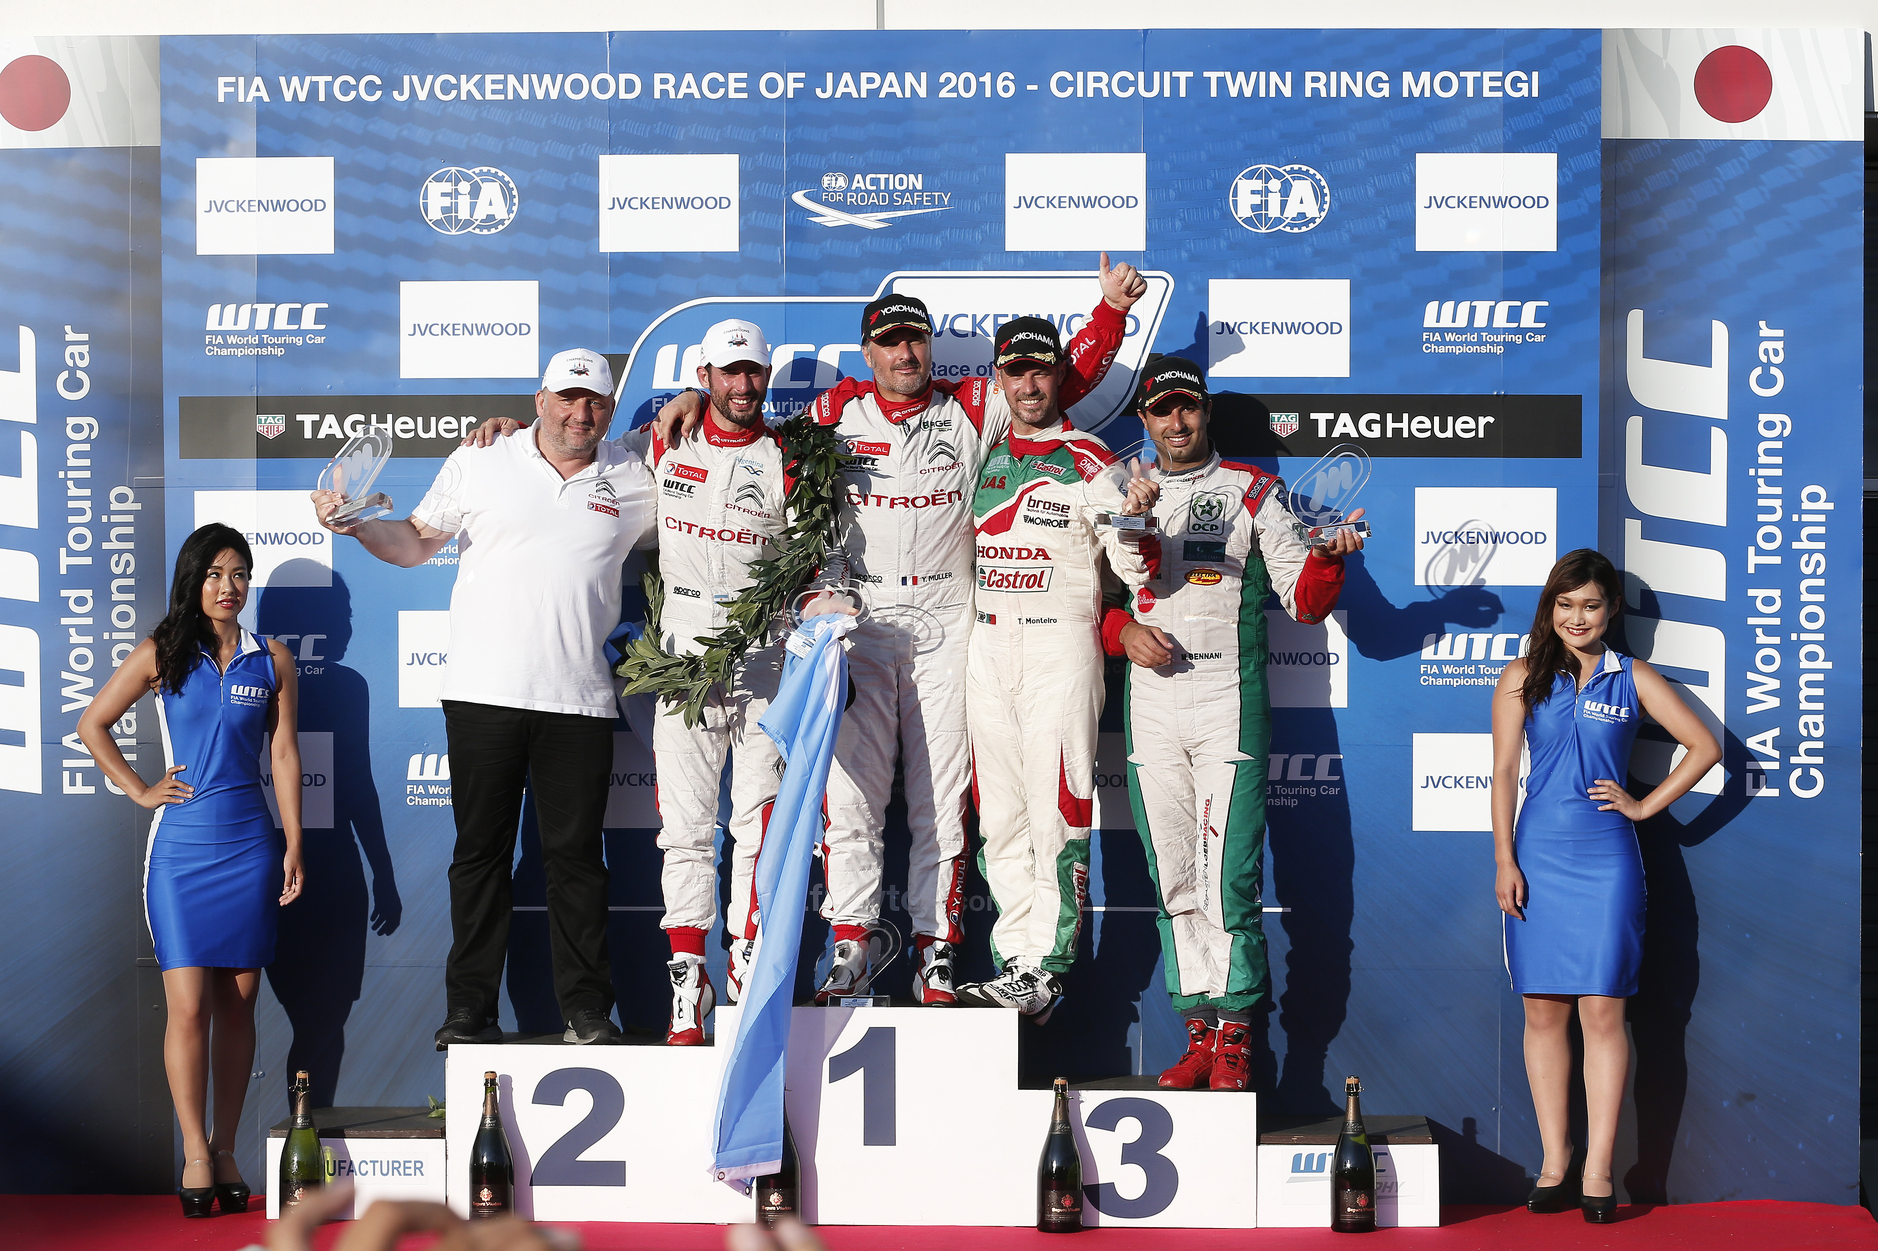
Lopez Wins FIA WTCC Title

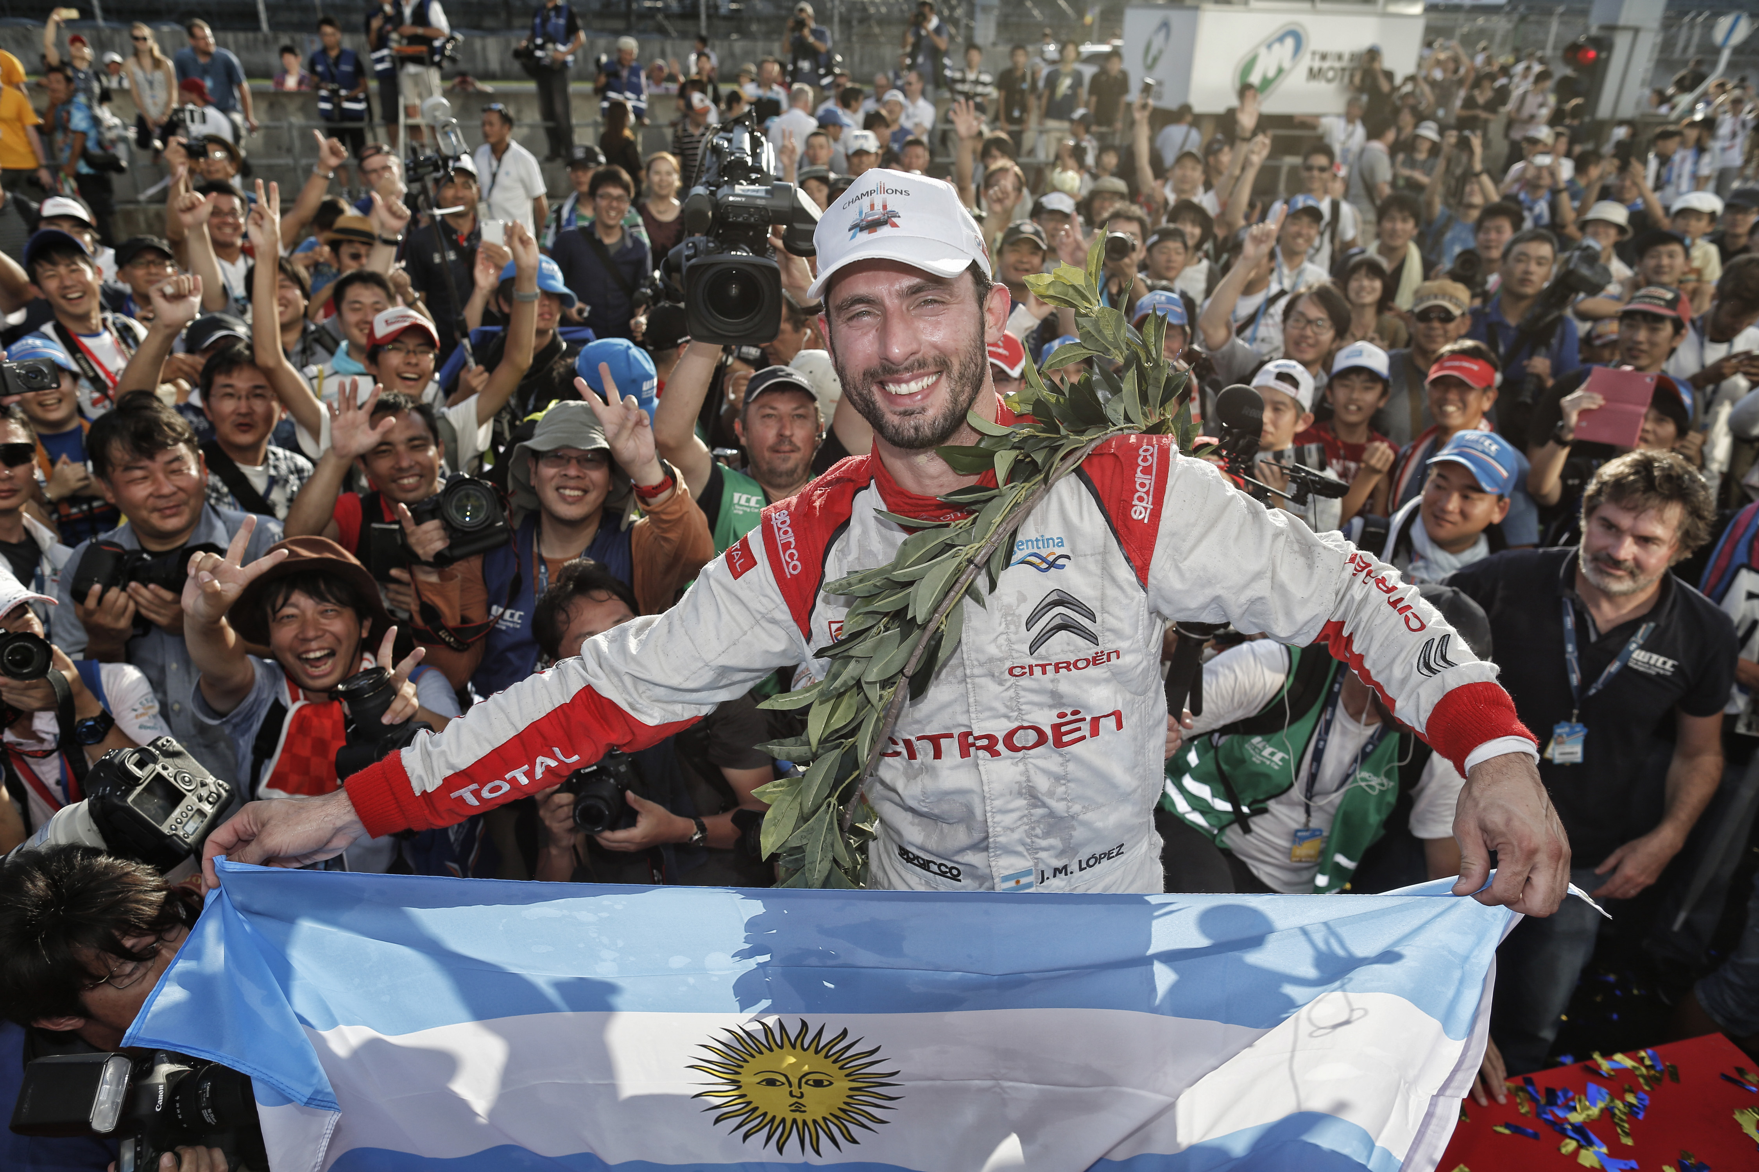
Lopez Celebrates in Japan

